**Name:**

**Advanced Programming in Java**

**Lab Exercise 1/3/2023**

1. **The Circle Class**

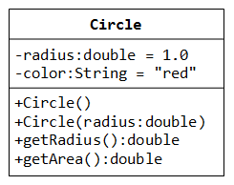

A class called **circle** is designed as shown in the following class diagram. It contains:

* Two private instance variables: radius (of type double) and color (of type String), with default value of 1.0 and "red", respectively.
* Two *overloaded* constructors;
* Two public methods: getRadius() and getArea().

Write a Circle class as well as a CircleTest class.

#### The Circle and Cylinder Classes Using Inheritance

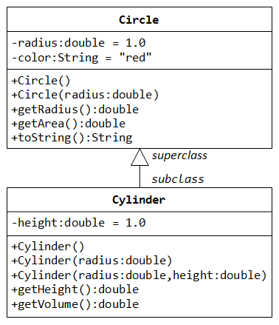

In this exercise, a subclass called Cylinder is derived from the superclass Circle as shown in the class diagram (where an an arrow pointing up from the subclass to its superclass). Study how the subclass Cylinder invokes the superclass' constructors (via super() and super(radius)) and inherits the variables and methods from the superclass Circle.

You can reuse the Circle class that you have created in the previous exercise. Make sure that you keep "Circle.class" in the same directory.

#### Circle and Cylinder using Composition

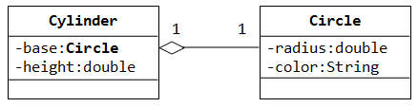

Try rewriting the Circle-Cylinder of the previous exercise using composition (as shown in the class diagram) instead of inheritance. That is, "a cylinder is composed of a base circle and a height".